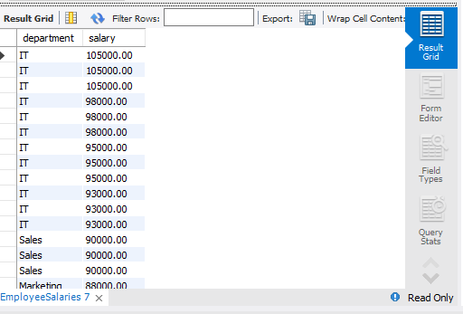

create database company_employee;

use company_employee;

CREATE TABLE EmployeeSalaries (

employee_id INT AUTO_INCREMENT PRIMARY KEY,

employee_name VARCHAR(100),

department VARCHAR(50),

salary DECIMAL(10,2),

hire_date DATE

);

INSERT INTO EmployeeSalaries (employee_name, department, salary, hire_date) VALUES

('John Smith', 'Sales', 75000.00, '2017-05-15'),

('Jane Doe', 'Marketing', 85000.00, '2018-03-20'),

('Michael Johnson', 'Sales', 90000.00, '2016-08-10'),

('Emily Brown', 'HR', 65000.00, '2019-01-05'),

('David Wilson', 'Marketing', 80000.00, '2017-10-25'),

('Jennifer Lee', 'IT', 95000.00, '2015-06-30'),

('Christopher Davis', 'Sales', 70000.00, '2020-02-12'),

('Jessica Martinez', 'IT', 105000.00, '2014-09-18'),

('Andrew Taylor', 'Marketing', 75000.00, '2018-07-15'),

('Elizabeth Anderson', 'HR', 60000.00, '2020-04-01'),

('Daniel Thomas', 'IT', 98000.00, '2017-12-10'),

('Sarah White', 'Sales', 82000.00, '2019-08-05'),

('Kevin Garcia', 'HR', 70000.00, '2016-03-08'),

('Laura Martinez', 'Marketing', 88000.00, '2017-04-22'),

('Robert Lopez', 'IT', 93000.00, '2018-11-15'),

('Amanda Harris', 'Sales', 78000.00, '2018-09-30');

SELECT department , salary

FROM EmployeeSalaries

GROUP BY employee_name;

SELECT department, salary

FROM EmployeeSalaries

ORDER BY salary DESC;